Here are some graphs when run the models from WandB

**Model 1**

Wandb name – tough-firefly-40

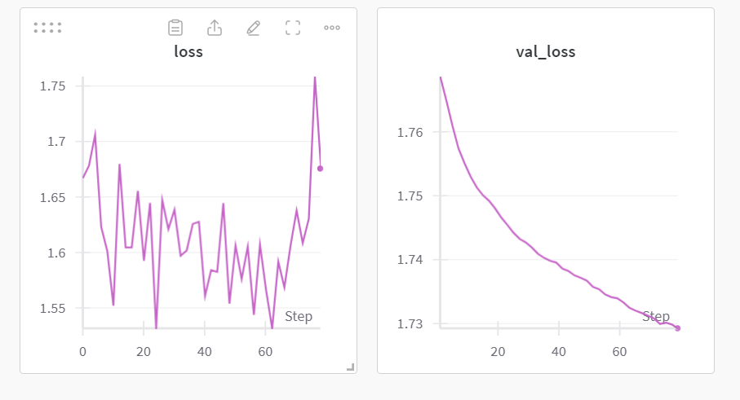

Wandb name - misunderstood-dragon-13

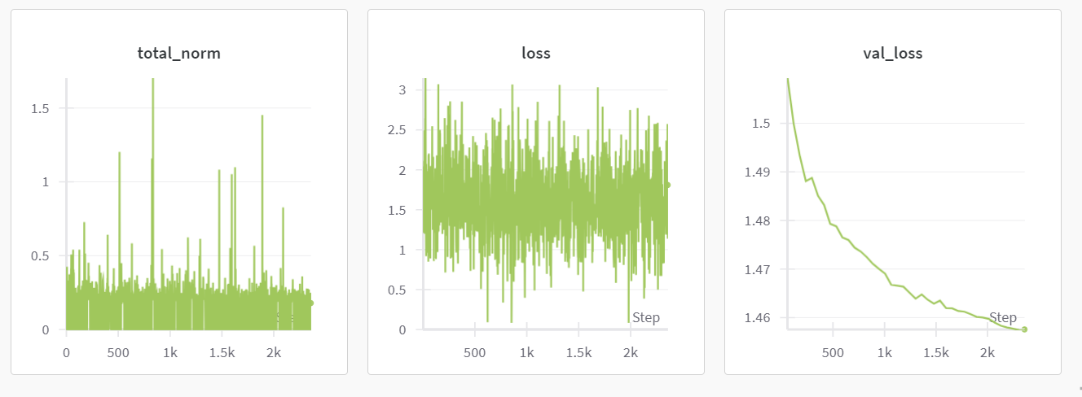

Model 2

Wandb name - flowing-vortex-49

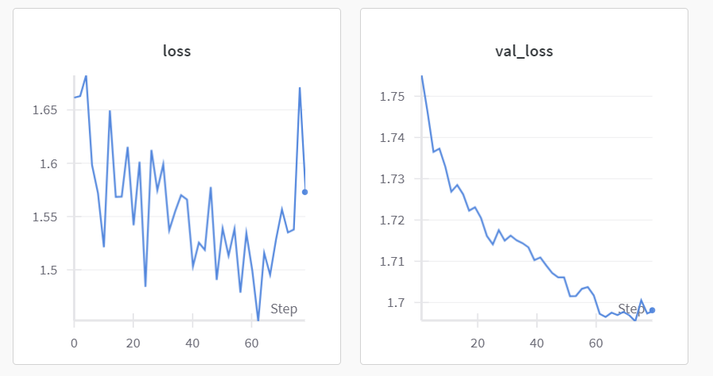

Wandb name – sage-glitter-41

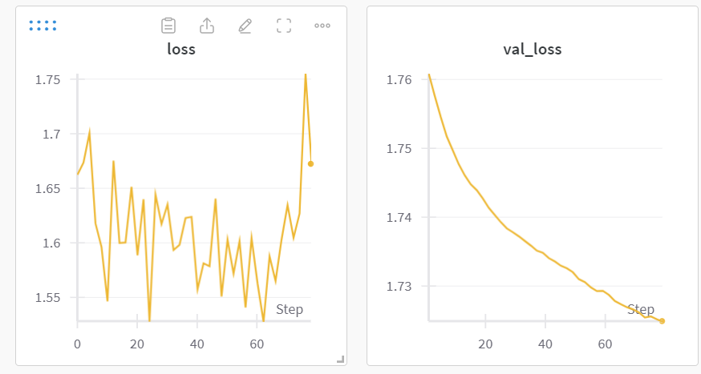

Wanb name – balmy-brook-15

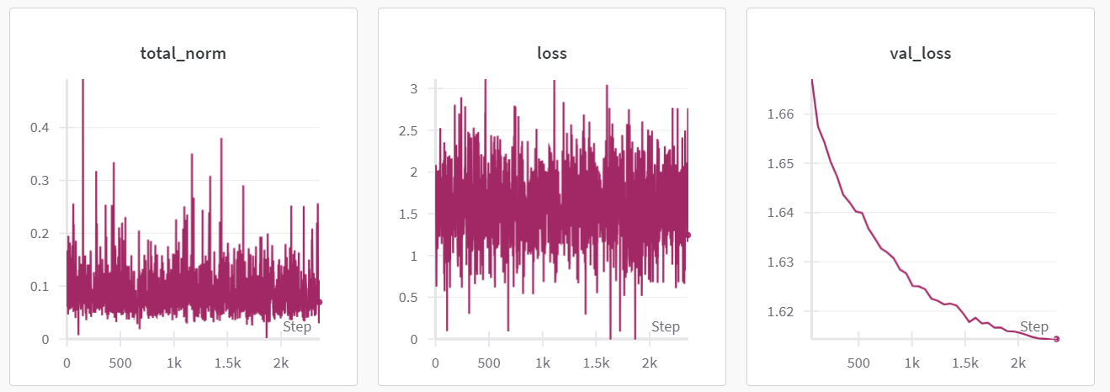

**Model 3 –**

Wandb name - ruby-tree-58

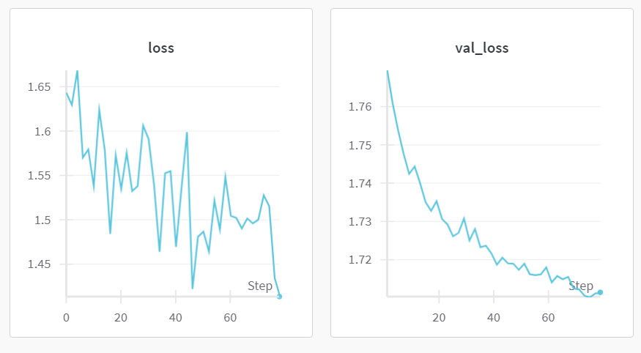

Wandb name - dark-darkness-37

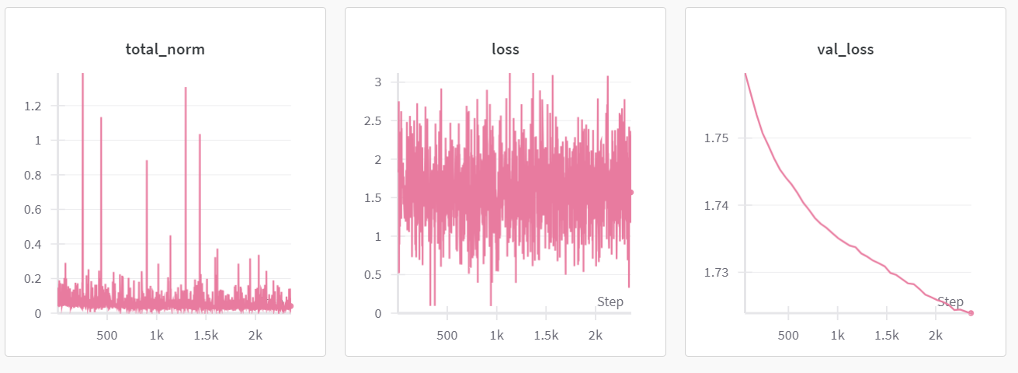

Model 4

Wandb name - dulcet-field-35

